**Sequence diagram**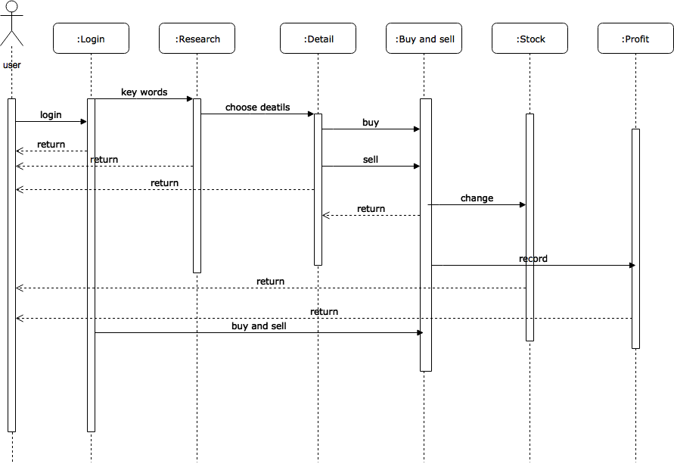 - **Wang Yi fan**